Research Project 7 Help Guide:

Go to your dataset in statcrunch.

For questions that are categories (like gender):

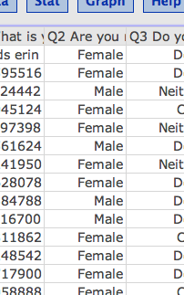

Assign each category a number – so here I’m going to do Male = 1, female = 2.

Create a new column that includes those numbers (so you don’t lose the original).

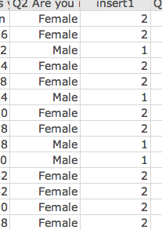

Now you can create a histogram of the numbered column:

(graph > histogram)

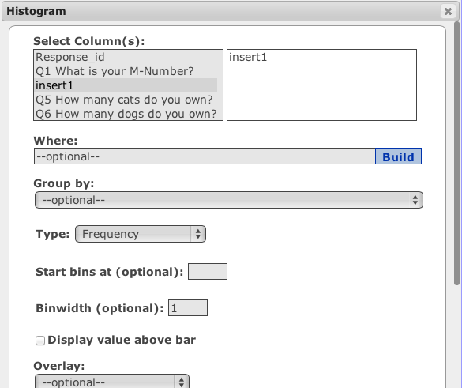

One thing I did was make the bin width = 1, so it wouldn’t give me decimals.

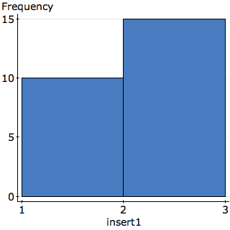

Then you would just include the labels in your RP7.

So like this:



1 = Male; 2 = Female

If you have lots of categories, you can use lots of numbers (i.e. majors questions) – or you can group them together in a way that makes sense to you.

If you are using a likert scale type data (agree-disagree stuff):

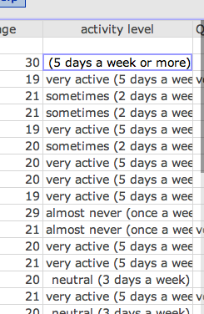

Assign the numbers based on the scale – so 1 would equal the lowest value, 2 second lowest value, etc. These types of questions you can average and have the numbers make sense, but you will have to change them from words to numbers first.